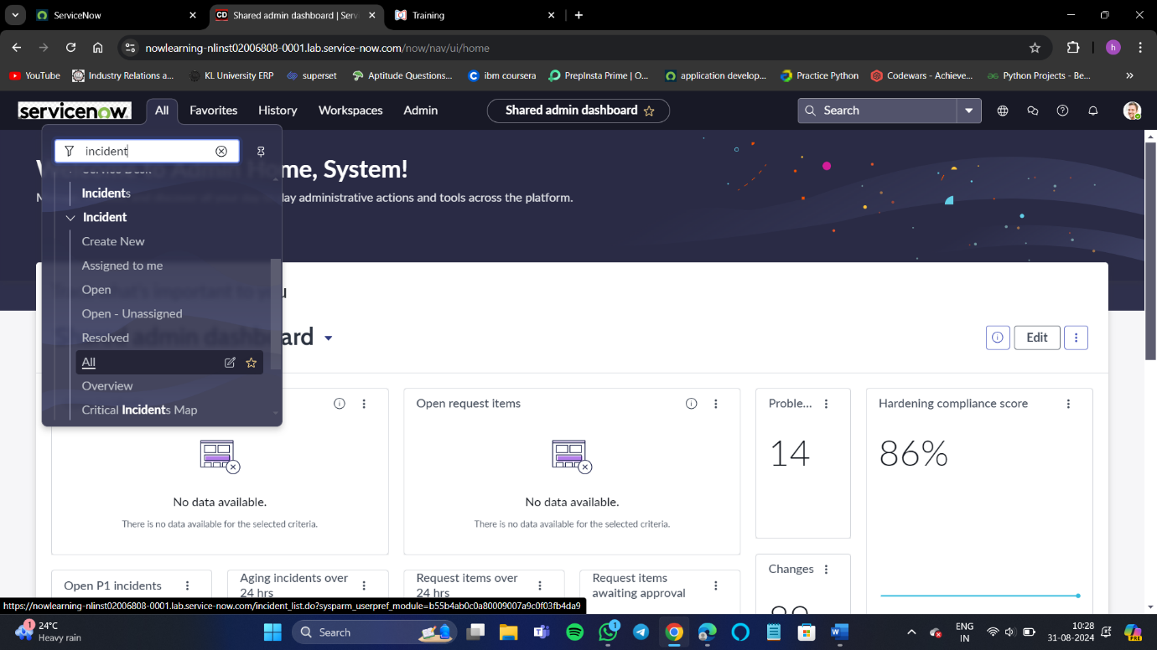**WEEK- 1 VIDEO- 7 REPORT**

